Leonardo da Vinci
Age group/class: 15– 16 years old
Lesson title: Leonardo da Vinci
School Discipline: History
Key concepts: to tell the history of a period and of a person through iconic images
Aims:
- Explain how history can be learnt using different resources
- Illustrate how history is important for connections between our present and our past, creating the basis for our future
- Understand the power of iconic images and audiovisual resources
Skills developed: observation, analysis and research
Materials/Equipment needed:
- Images related to the subject of lesson plan
- A video to understand and have an introduction for the argument
- VR headset
- VR video / link
- a collection of “historical images” to be used during the follow up session
Lesson plan:
Stages | Description of activity | Time
Preparation before the lesson | If this is a first VR experience for students – go through the safety rules:  - Learners are to sit down whilst using the VR glasses and not hold anything in their hands, unless the experience is of such a nature that it requires you standing, in which case, ensure enough space is allowed around all students.  - Learners will be told to expect a feeling of vertigo. If it gets worse, students must remove VR glasses.  - Learners need to know how to adjust the viewing focus before using the headsets.  - Learners must not use the headset when they are: tired, need sleep, under emotional stress or anxiety, when suffering from cold, flu, headaches, migraines as this can worsen their susceptibility to adverse reactions.  - Learners should be given the choice to opt out of using VR.
Introduction | Share Learning Intentions with students  The aim of the current lesson plan is to explain students how history can be learnt from different perspectives. For example, an important period of Italian history can be learnt through one of its most iconic images, the prancing horse. The biography of Leonardo Da Vinci, well known scientist, artist, inventor represents the starting point of the current lesson plan.  Teacher shows a picture of the Vitruvian Man .  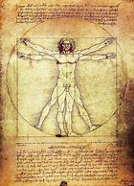  Does anybody know this famous image?  - what does it represent?  - where did you see it?  Teacher shows the video summarising up the history of Leonardo da Vinci, asking students to pay attention to the quoted historical events, as they will represent the starting point of the guided discussion. | 10 min.
Initial Immersive Experience | “And now let’s go inside the atmosphere of the Leonardo da Vinci Biography”:  https://youtu.be/bHszEk9jooM  Learners put on the VR headsets and explore the video with the support of the teacher. This experience offers students the opportunity to concretely live the atmosphere, the emotions of the historical events they are studying. | 20 min.
Guided Immersive Experience | Teacher asks students to watch again the video Once again, teacher asks students to pay attention to the historical events mentioned in the video, as they will be part of the formative assessment. | 5 min.
Follow up | 1) History by images  “History is made up by dates, events, anecdotes, secrets…but images have a crucial role. The Vitruvian Man is an iconic image of Genius Leonardo Da Vinci, Italy and a period of Italian history. Do you recognise the following historical / iconic images? You can eventually make a research on the net.  Image 1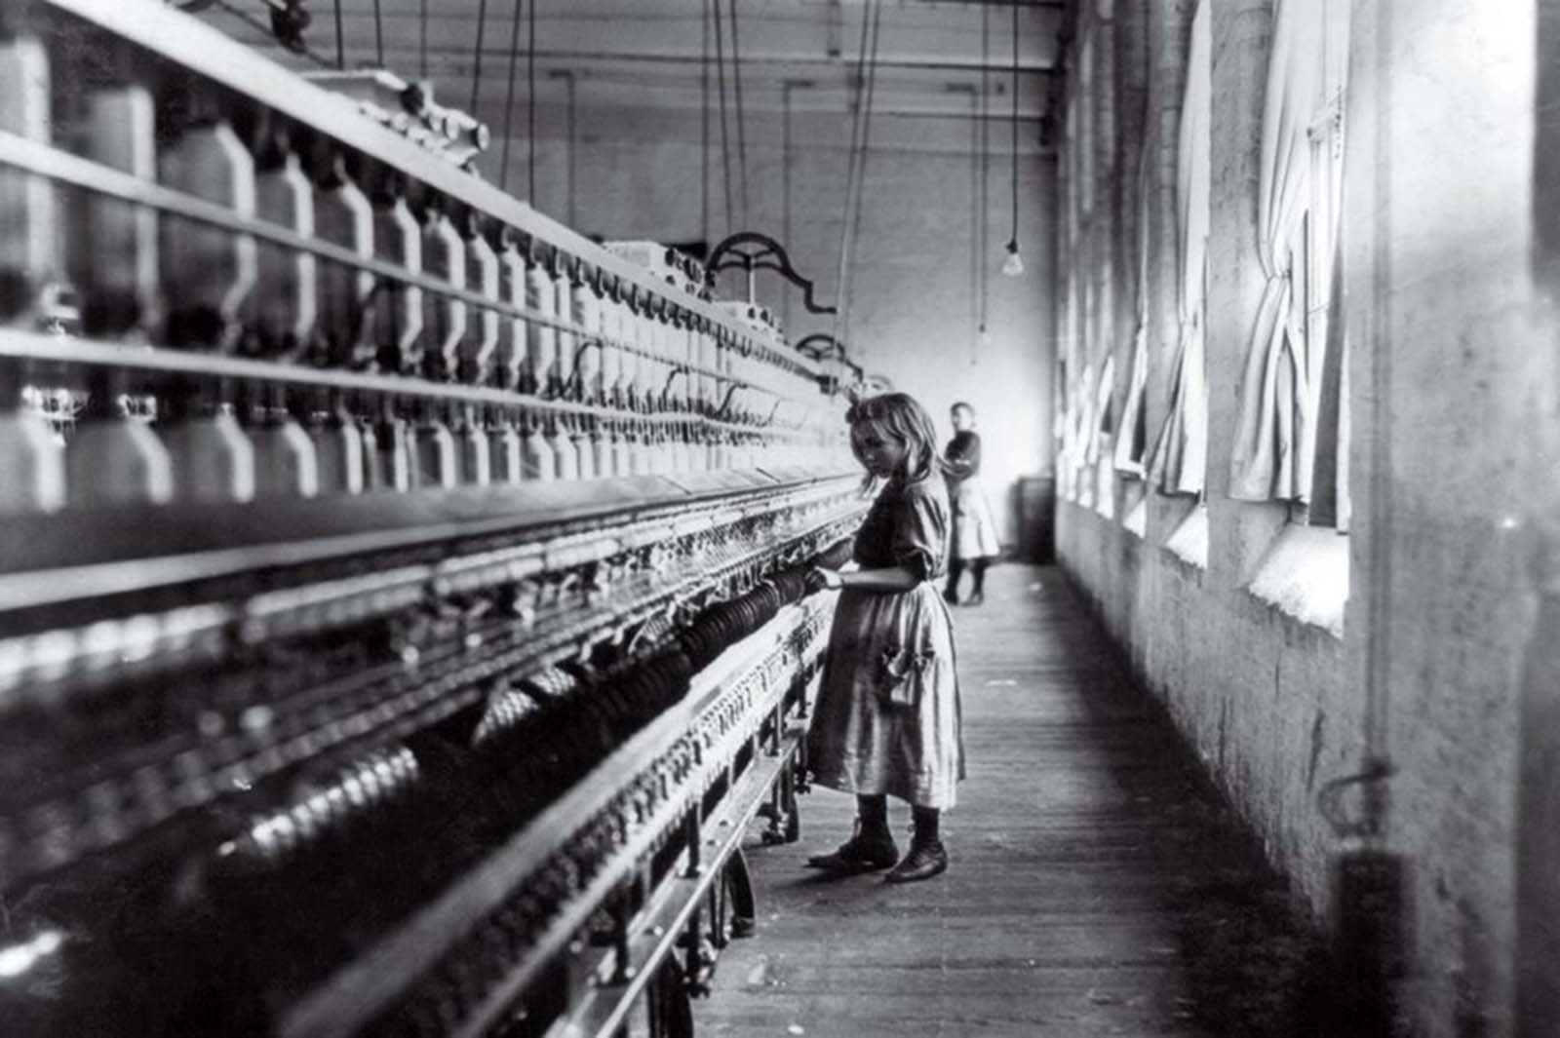  Image 2  Image 3  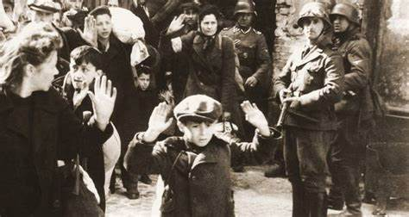  Image 4  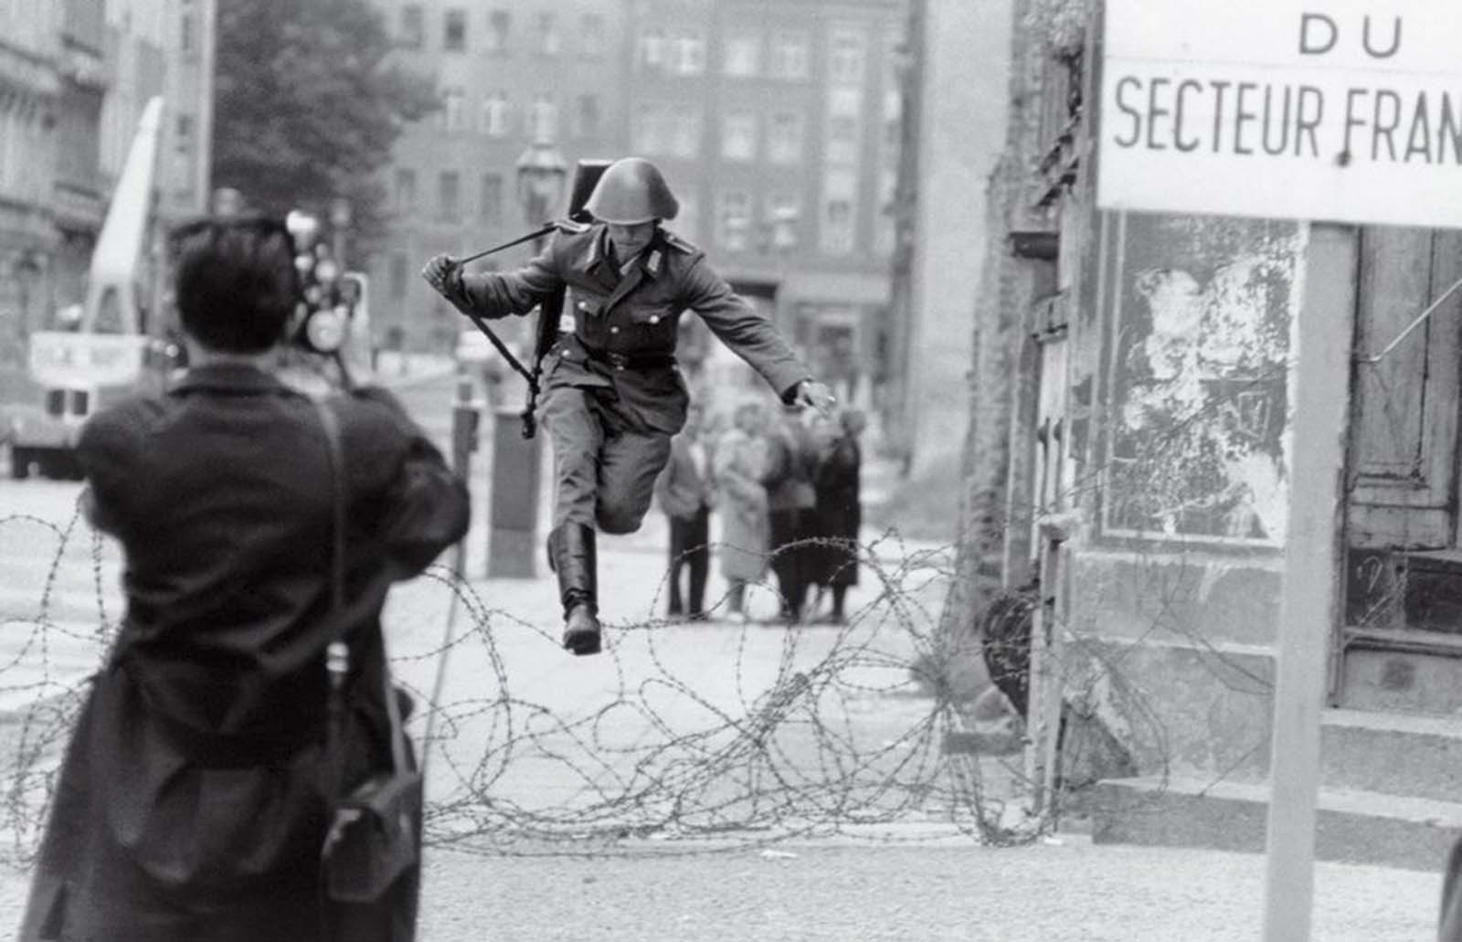  2) Group work  Students, divided into groups, are asked to identify further historical / iconic images officially belonging to the collective memory. Then, one representative for each group is asked to presents the results achieved during the group work.  3) Universal symbols  “The Vitruvian Man is universally recognized as the symbol of Leonardo Da Vinci’s Genius. Do you know any other symbol or logo which work as a universal symbol, which allow to connect quickly a famous protagonist or genius of history (art, science and similar)? | 10 min.  10 min.  5 min
Formative Assessment | - “How many historical events were mentioned in the videos?”  - “When did Leonardo da Vinci go to Milan?”  - “Which historical period belong Leonardo Da Vinci to?”

